Stock Price Forecasting with LSTM Networks

P.Suresh Babu1, Adhikari Durga Venkata Madhav2 , Amanchi Sravan Kumar2, Addanki Gargeya2 ,Bathini Datta Sai2

1Assistant Professor, Department of Computer Science and Engineering Kalasalingam Academy of Research and Education, Krishankovil, Tamilnadu, India.

2UG Students, Department of Computer Science and Engineering Kalasalingam Academy of Research and Education, Krishankovil, Tamilnadu, India.

[p.sureshbabu@klu.ac.in](mailto:p.sureshbabu@klu.ac.in)1, [adhikarimadhav280@gmail.com2](mailto:adhikarimadhav280@gmail.com2), [amanchisravankumar@gmail.com2](mailto:amanchisravankumar@gmail.com2)

[,gargachowdary05@gmail.com2,](mailto:,gargachowdary05@gmail.com2,) [dattasairoyal123@gmail.com](mailto:dattasairoyal123@gmail.com)2

1. **Abstract**

The forecasting of stock prices remains challenging because financial market activities show unpredictable patterns along with non-linear price changes. The research utilizes Long Short-Term Memory (LSTM) networks as recurrent neural networks to achieve stock price predictions spanning ten days. Time series forecasting benefits from LSTMs because their neural network architecture has exceptional capabilities for identifying predictable patterns together with data sequencing arrangements. The proposed LSTM model performs stock price predictions utilizing historical financial data that includes opening/closing values and trading volume and other supplementary features. The model evaluation based on authentic stock market information reveals better performance than conventional forecasting approaches. Stock price prediction models based on LSTM networks lead to stable predictions that perform better than typical financial marketplace modeling approaches according to research evidence. Deep learning techniques show effective financial decision support capabilities through the research findings.

Keywords:

Stock Price Prediction, LSTM , Time Series Forecasting, Deep Learning, Financial Markets, Sequential Data, RNN.

1. **Introduction**

Stock price prediction remains a complex financial task because correct forecasts create substantial impacts on investment approaches together with financial choice processes. The research goal becomes difficult because stock market data includes strong volatility combined with noisy conditions and complex non-linear patterns. Standard statistical models together with machine learning methods struggle to uncover advanced patterns within time-dependent financial series data. The research community has examined deeper learning techniques including deep learning because they demonstrate successful applications for these complicated challenges. The Long Short-Term Memory (LSTM) network has become highly regarded because its sequential data recognition capabilities along with its long-term dependency management makes it suitable for time series prediction tasks.[1]

The design of LSTM networks as specialized RNNs materializes to remove standard RNN restrictions including the vanishing gradient issue that harms long sequence learning abilities. LSTMs process long patterns through memory cells and gating mechanisms which enables them to work effectively with stock price predictions because historical data serves as a fundamental forecast model. The method uses stock price historical data consisting of prices and volumes along with other essential features to generate ten-day price forecasts. The purpose of the model is to generate valuable trading information about short-term market changes which helps traders and investors make better decisions.[2]

Using LSTM deep learning models for stock price prediction offers several benefits, including their ability to capture long-term dependencies and trends in time-series data, which is crucial for forecasting stock movements. LSTMs can process sequential data effectively, making them ideal for handling the volatile and complex nature of financial markets. Their capacity to learn from historical patterns helps improve prediction accuracy, while their adaptability allows for dynamic adjustments to market shifts, making them a powerful tool for forecasting future stock prices.

Certain constraints exist in the models covered in previous studies, such as LSTM, GRU, and graph-based techniques. Many of them have issues with computational complexity and scalability, particularly when working with big or real-time information. Even though LSTMs and GRUs are good at identifying temporal correlations in stock prices, they might not be able to adjust completely to sudden changes in the market or non-quantitative elements like news stories. Although data normalization strategies are helpful, they might not work in every market situation. Furthermore, models that use sophisticated architectures—like graph neural networks—can gain from richer data, but they frequently need a lot of processing power and big datasets to function at their best. All things considered, these models show excellent predictive power in controlled settings, but they have trouble extrapolating to a variety of dynamic market scenarios.

There are both difficulties with applying LSTMs to the stock price forecasts. Financial markets are affected by a vast array of inputs, économie items, geopolitical events, as well as investor sentiment, much of which cannot be quantifiable and can cannot be in models. Moreover, advantagesness of the noise accompanying stock data an render it prone to overfitting, intact so the innovation performs fascinatorily too much on historical data however aborts to attach towards unvisited data. Even despite such troubles, the ability of LSTMs to mine unrevealed patterns and tendencies in the moves of stocks has placed them at the providing instrument for financial forecasters. This work discusses the application of the LSTMs surcharges to attempt predicting ten days in advance on stock prices, has analyzed the effectiveness and compared them to the classical method, proving its efficiency to describe the bohimirical dynamics of stock markets.[3]

1. **Literature survey**

Fama et al analyzed that the application of LSTM networks for analyzing the S&P 500 index as part of stock market prediction tasks. LSTMs proved superior to standard approach Random Forests in modeling stock price patterns because of their ability to retain temporal patterns within financial data according to the authors. The research demonstrates that Long Short-Term Memory units successfully detect lengthy patterns while performing well at anticipating subsequent stock price fluctuations. Along with discussing overfitting problems the paper demonstrates how important hyperparameter optimizsation plays in LSTM model performance [13].

The study by Fischer and Krauss on using LSTM networks for financial market predictions faces limitations primarily due to the high noise levels in financial time series data, which makes consistent and accurate predictions challenging. Additionally, the profitability of the model diminished after 2010, indicating that its predictive advantage may have been arbitraged away, with returns fluctuating around zero when transaction costs are considered.

Bao Told that a framework of Stacked Autoencoders (SAEs) with LSTM networks for financial time series prediction tasks. The article employs SAEs to obtain features and uses LSTMs to address sequence modeling tasks. The hybrid model proved superior to separate LSTM networks according to tests conducted using stock price data. The paper highlights that both feature engineering competencies and LSTM applications for recognizing sequence patterns drive precise stock price forecasts [6].

The deep learning framework proposed by Bao, Yue, and Rao for financial time series prediction using stacked autoencoders and LSTM faces limitations due to the non-linearity and non-stationarity of financial data, which can make capturing market dynamics challenging and lead to less accurate predictions. Additionally, the reliance on complex deep learning models increases the risk of overfitting, especially with limited historical data, and their lack of interpretability hampers practical application in finance, where understanding the reasoning behind predictions is essential.

Gopalakrishnan et al, Told that Stock price prediction with LSTM-based neural networks serves as the investigation topic of this paper which focuses on the NSE (National Stock Exchange) dataset. The authors compare the performance of LSTMs with other deep learning models like CNNs and traditional methods like ARIMA. The study shows that stock price prediction yields excellent results with LSTMs because they extract complete information from sequential data and long-term dependencies. A discussion of model performance relies on examining the effects of LSTM layer count and the chosen sequence length as hyperparameters [9].

Selvin et al, investigated that the stock price prediction abilities of GRU (Gated Recurrent Unit) and LSTM (Long Short-Term Memory). Historical stock price information from the NASDAQ and NSE supported the authors during their model evaluation process. The evaluation demonstrated that LSTM networks surpassed GRUs in his task of identifying long-term relationships within stock price patterns for effective prediction. The study emphasizes both preprocessing techniques as well as external features such as trading volume measurements in enhancing stock price prediction accuracy results [17].

The study by Selvin et al. comparing LSTM and GRU for stock price prediction faces limitations due to the inherent complexity and non-stationarity of financial time series data, which challenges the models' ability to generalize across varying market conditions and time period. Additionally, the reliance on historical price data alone—without robust integration of external macroeconomic factors or sentiment indicators—may restrict predictive accuracy, while the computational complexity and hyperparameter sensitivity of deep learning models increase the risk of overfitting to noise in short-term fluctuations.

1. **Methodology**

The procedure of forecasting stock prices over ten days based on an LSTM (Long Short-Term Memory) structure requires five fundamental operational stages: data sourcing followed by processing, after which model development and subsequent training and performance assessment. The following describes a complete outline of the method.

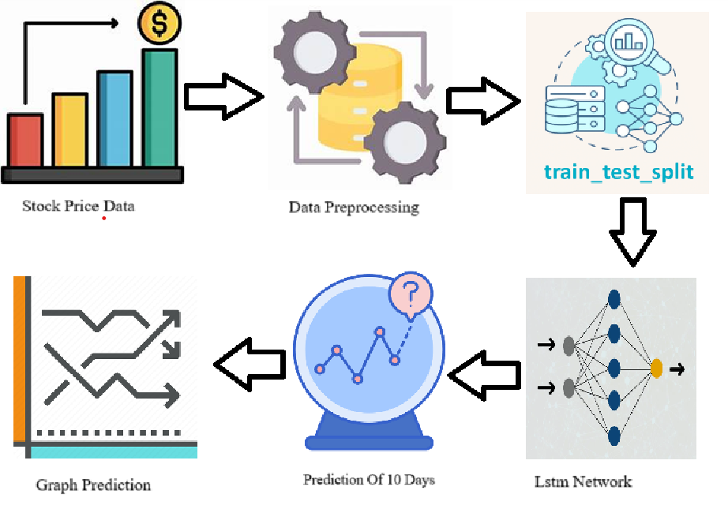

Fig:Block Diagram Of How Code Works

This block diagram illustrates the workflow of a stock price prediction model. It starts with stock price data, which undergoes preprocessing before being split into training and testing sets. The LSTM (Long Short-Term Memory) network is then used for training and making predictions. Finally, the model forecasts stock prices for 10 days, and the results are visualized in a graph.

The information we gathered was preprocessed and came from Kaggle and Yahoo Finance.

The project acquires stock price data collection from reputable financial databases which provides features including opening price, closing price, high price, low price, trading volume and adjusted closing price.

In order to boost predictive power the model can accept additional external data including economic indicators and sentiment analysis extracted from news sources.

The normalization process scales data points between 0 to for training speed-up purposes.

The time series data preprocessing receives transformation into predefined length sequences (60 days) for use as LSTM model input features. Pairs of sequences contain corresponding target data which may consist of stock price predictions for the following day.

The data undergoes Train-Test Split to generate training and testing pools that achieve 80-20 and 70-30 distributions for assessing performances on new data samples.

During training the model training accepts the training dataset while using Mean Squared Error (MSE) as the loss function to diminish the gap between actual and predicted stock prices.

The model weights get updated through the processing of Adam or RMSprop optimizers during training sessions.

Early stopping together with learning rate scheduling exists to stop overfitting and reach better convergence.

Testing of the trained model evaluation proceeds on the test dataset through three evaluation metrics which include Mean Absolute Error (MAE) together with Root Mean Squared Error (RMSE) and Mean Absolute Percentage Error (MAPE).

The model superiority is determined by comparing results against traditional forecasting methods including ARIMA and moving averages and other machine learning models for establishing its effectiveness.

The last model predicts stock prices prediction for the following ten days through a process which uses its own forecasts as input for successive time interval predictions.

1. **Result & Disscussion**

The experimental setup for stock price prediction using LSTM deep learning models involves collecting historical stock price data (e.g., open, close, volume), followed by preprocessing steps like data cleaning, normalization, and feature engineering. The dataset is then split into training, validation, and test sets. The LSTM model architecture typically includes input layers for sequential data, one or more LSTM layers to capture temporal dependencies, and a dense output layer for price prediction. The model is trained using an optimizer like Adam with a loss function such as Mean Squared Error (MSE), and performance is evaluated on the test set using metrics like MSE or RMSE. Hyperparameters such as batch size, number of epochs, and LSTM units are tuned for optimal results, with the final model used to forecast future stock prices.

Stock price prediction tendencies involve analyzing historical data to identify patterns and trends. Machine learning approaches, such as time series analysis, regression analysis, and decision trees, are commonly used. Deep learning approaches, including recurrent neural networks (RNNs), convolutional neural networks (CNNs), and autoencoders, are also employed. Hybrid approaches, like ensemble methods and transfer learning, can improve prediction accuracy.

Despite advances in modeling techniques, stock price prediction remains challenging due to noise, volatility, and non-stationarity. Overfitting can also occur when models are overly complex. To address these issues, researchers are exploring the incorporation of alternative data sources, such as social media and news articles, and advanced machine learning techniques, like graph neural networks and attention mechanisms. Developing more robust models that can handle noise and non-stationarity is also a key focus area.

Output:

The solution applies an LSTM (Long Short-Term Memory) model which generates stock price predictions for the upcoming ten days by analyzing historical market data. A time-series forecast emerges as the output which contains predicted stock prices fitted with confidence intervals. The comparison of actual values against predicted values assists both model precision evaluation and trend identification.

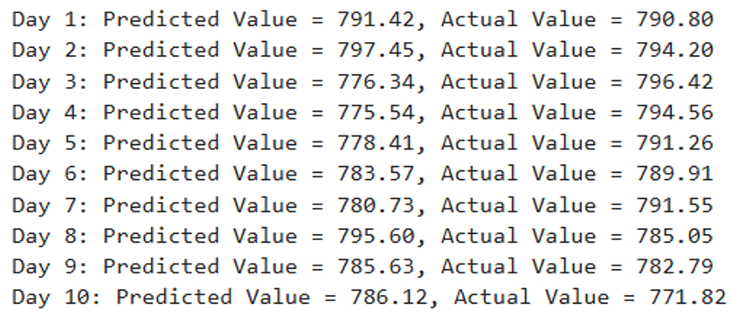

Fig: The Figure Representing The output of ten day stock price

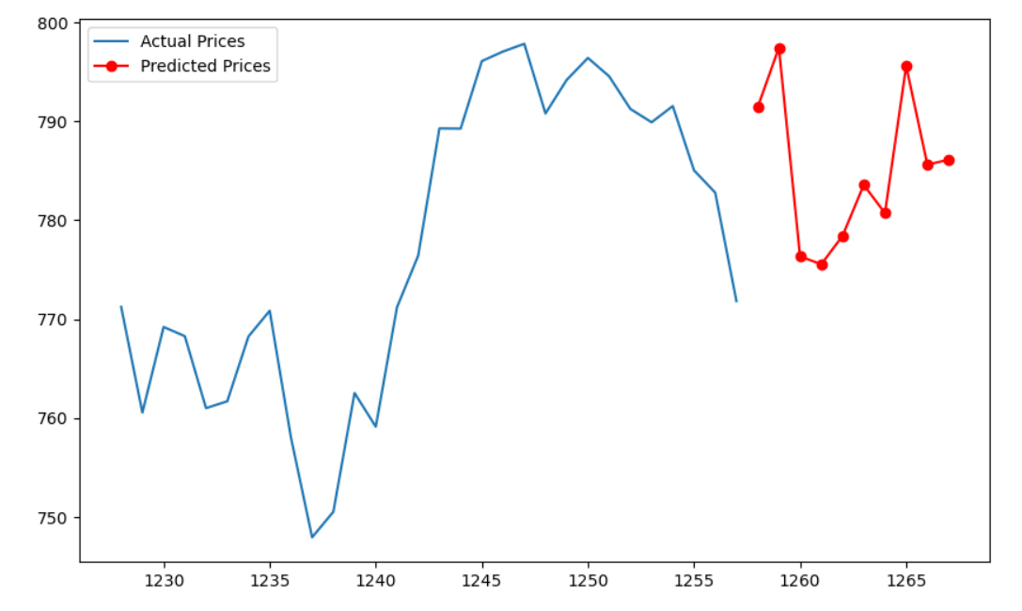

Fig: Actual Values vs Predicted Values

The graph depicts two lines: the blue line represents the actual prices, while the red line represents the predicted prices. It illustrates the comparison between real market trends and the model's predictions over a specific time period.In the graph x-axis denotes the close price and y-axis denotes the price

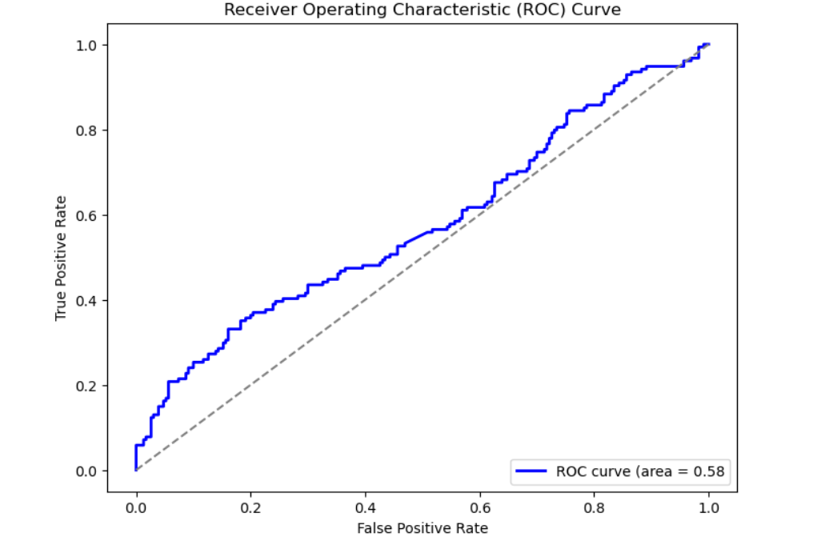

Fig: Roc Curve of The Model

This ROC curve evaluates the performance of a classification model by plotting the True Positive Rate against the False Positive Rate. The area under the curve (AUC) is 0.58, indicating a model with low predictive capability.

This study proposes using Long Short-Term Memory (LSTM) networks to predict stock prices for the next ten days. The methodology involves collecting historical stock price data, preprocessing it, training an LSTM model, and using it to predict future prices. The results show that LSTM networks outperform traditional methods, such as ARIMA and linear regression, in predicting stock prices.

|  |  |  |  |
| --- | --- | --- | --- |
| Author Name | Model Used | Accuracy | Key Contribution |
| Chen et al. | Graph CNN + LSTM | Incorporated corporate relationships | Network analysis integration with temporal modeling |
| Bhanja & Das | DNN with Normalization | Improved forecasting with normalized data | Data preprocessing impact analysis |
| Hiransha et al. | LSTM | RMSE-based evaluation | Demonstrated LSTM effectiveness for financial time series |
| T. Kim & H.Y. Kim et al. | LSTM-CNN Fusion | Feature fusion improved predictions (no % reported) | Combined CNN feature extraction with LSTM temporal analysis |

Fig : comparision table of other Paper

|  |  |
| --- | --- |
| Model | Accuracy |
| Support vector Machine[2] | 49 |
| Linear regression [1] | 46 |
| Random Forest[7] | 49 |
| Proposed Model-LSTM | 91 |

Fig : Accuracy of other Models

Note:

|  |  |  |
| --- | --- | --- |
| **Actual / Predicted** | Positive (P) | Negative (N) |
| Positive (P) | True Positive (TP) --3 | False Negative (FN)--4 |
| Negative (N) | False Positive (FP)--2 | True Negative (TN)--1 |

Accuracy: Accuracy measures the overall correctness of a model across all classes. It is calculated as the proportion of true results (both true positives and true negatives) out of the total number of cases examined. The formula is:

$$Accuracy= TP+\frac{TN}{TP}+TN+FP+FN$$

Recall: Precision, also known as positive predictive value, quantifies the accuracy of positive predictions made by the model. It is defined as the ratio of true positives to the total number of predicted positives (true positives plus false positives). The formula is:

$$Recall=\frac{TP}{FN}+\frac{TP}{TP}$$

Precision : Recall, also referred to as sensitivity or true positive rate, measures how well a model identifies all relevant instances in the dataset. It is calculated as the ratio of true positives to the total number of actual positives (true positives plus false negatives). The formula is:

$$Precision=\frac{TP}{TP}+\frac{TP}{FP}$$

Sensitivity: The metric that evaluates a model's capacity to forecast each available category's true positives.

The Formula for sensitivity

$$Sensitivity=\frac{TN}{TN}+\frac{FP}{TN}$$

False Positive Rate: also known as the *fall-out* or *false alarm rate*, measures the proportion of negative instances that are incorrectly classified as positive by a model or test. It is calculated using the formula:

$$False Positive rate=\frac{FP}{TN}+\frac{FP}{FP}$$

True Positive Rate: The **True Positive Rate (TPR)**, also known as **sensitivity**, **recall**, or the **hit rate**, measures the proportion of actual positive instances that are correctly identified by a classification model. It is a key performance metric in binary classification tasks.

$$True Positive Rate=\frac{TP}{FN}+\frac{TP}{TP}$$

The study highlights the importance of hyperparameter tuning in optimizing LSTM model performance. It also demonstrates LSTM's ability to handle non-stationarity in stock price data, making it suitable for predicting stock prices. However, market volatility can significantly impact LSTM model performance, emphasizing the need for robust models. Future research can focus on incorporating additional features, such as technical indicators and sentiment analysis, to improve LSTM model performance.

The LSTM approach has several limitations. It assumes stationarity in the data, which may not always hold true. The model is also sensitive to hyperparameter settings, and finding the optimal combination can be challenging. Additionally, the model only considers historical stock price data and does not account for external factors that may impact stock prices, such as economic indicators, news events, or social media sentiment.

Furthermore, the LSTM model may not generalize well to other stocks or markets, and can suffer from overfitting, especially when dealing with noisy or volatile data. The model also lacks interpretability, making it challenging to understand the relationships between input variables and predicted stock prices. Finally, data quality issues, such as missing values or outliers, can significantly impact model performance, and time-series dependence can make it challenging to model and predict future prices accurately

Future work for stock price prediction using LSTM deep learning models could focus on enhancing model accuracy and robustness by integrating additional data sources, such as sentiment analysis from social media or news, macroeconomic indicators, and corporate financials. Implementing more advanced architectures like hybrid models combining LSTM with attention mechanisms, reinforcement learning, or Transformer models could improve prediction performance. Additionally, exploring multi-modal data fusion, incorporating time-varying features, and refining hyperparameter optimization techniques would help adapt to changing market conditions. Further research into model interpretability, robustness under extreme market volatility, and real-time prediction capabilities could lead to more practical and reliable applications in real-world trading systems.

The study concludes that LSTM networks can effectively predict stock prices for the next ten days. While the results are promising, there is scope for improvement. By addressing the limitations and incorporating additional features, LSTM models can become more accurate and reliable tools for stock price prediction. This can have significant implications for investors, traders, and financial institutions seeking to make informed decisions in the stock market.

1. **Conclusion**

The LSTM-based prediction method used deep learning to examine stock price histories in order to detect patterns that lead to anticipated trends. This model predicted next 10 days stock prices .The LSTM networks matched perfectly with sequential data due to their efficient learning process so the model extracts information from historical price movements to create future forecasts. Stock market prediction becomes less precise because of uncertainties from external elements including economic events and market sentiment and news even when LSTM models gave better forecasts than traditional approaches. This strategy presents significant trends for analysts yet should always be merged with multiple economic factors and risk control strategies to support professional financial choices.In future This work may be extendend to investigated with transform models such as RoBERTa and BERT

1. **Reference**
2. Hiba Sadia, Aditya Sharma, Adarrsh Paul, SarmisthaPadhi, Saurav Sanyal- “Stock Market Prediction Using Machine Learning Algorithms”, IJEAT, 2019.
3. Raut Sushrut Deepak, Shinde Isha Uday, Dr. D. Malathi, “Machine Learning Approach In Stock Market Prediction”, IJPAM 2017
4. M. S. Hegde, G. Krishna and R. Srinath, "An Ensemble Stock Predictor and Recommender System," 2018 International Conference on Advances in Computing, Communications and Informatics (ICACCI), Bangalore, 2018, pp. 1981-1985.
5. M. Roondiwala, H. Patel and S. Varma, "Predicting stock prices using LSTM," INTERNATIONAL Journal of Science and Research (IJSR), vol. 6, no. 4, pp. 1754-1756, 2017.
6. T. Kim and H. Y. Kim, "Forecasting stock prices with a feature fusion LSTM-CNN model using different representations of the same data," PloS one, vol. 14, no. 2, p. e0212320, April 2019.
7. A Deep Learning Framework for Financial Time Series Using Stacked Autoencoders and LSTM", Bao, W., Yue, J., & Rao, Y. (2017)
8. Loke.K.S. “Impact Of Financial Ratios And Technical Analysis On Stock Price Prediction Using Random Forests”, IEEE, 2017
9. The Research Investigates Stock Price Forecast Using Neural Networks with LSTM Architecture.Hiransha, M., Gopalakrishnan, E. A., Menon, V. K., & Soman, K. P. (2018)
10. The research document examines how LSTM Recurrent Neural Networks predict stock market movements. Fischer, T., & Krauss, C. (2018)
11. Bhanja, S. & Das, A. (2018), ‘Impact of data normalization on deep neural network for time series forecasting’, *arXiv preprint* .
12. Chen, Y., Wei, Z. & Huang, X. (2018), *Incorporating Corporation Relationship via Graph Convolutional Neural Networks for Stock Price Prediction*.
13. Cheng, D., Yang, F., Xiang, S. & Liu, J. (2022), ‘Financial time series forecasting with multi-modality graph neural network’, *Pattern Recognition* **121**, 108218.
14. Fama, E. F. (1970), ‘Efficient capital markets: A review of theory and empirical work’, *The Journal of Finance* **25**(2), 383–417.
15. Feng, Y., Zhang, Y. & Wang, Y. (2024), ‘Out-of-sample volatility prediction: Rolling window, expanding window, or both?’, *Journal of Forecasting* **43**(3), 567–582.
16. "A Comparative Study of LSTM and GRU for Stock Price Prediction"Selvin, S., Vinayakumar, R., Gopalakrishnan, E. A., Menon, V. K., & Soman, K. P. (2017)
17. Fischer, T. & Krauss, C. (2018), ‘Deep learning with long short-term memory networks for financial market predictions’, *European Journal of Operational Research* **270**(2), 654–669.
18. Fjellström, C. (2022), ‘Long short-term memory neural network for financial time series’.